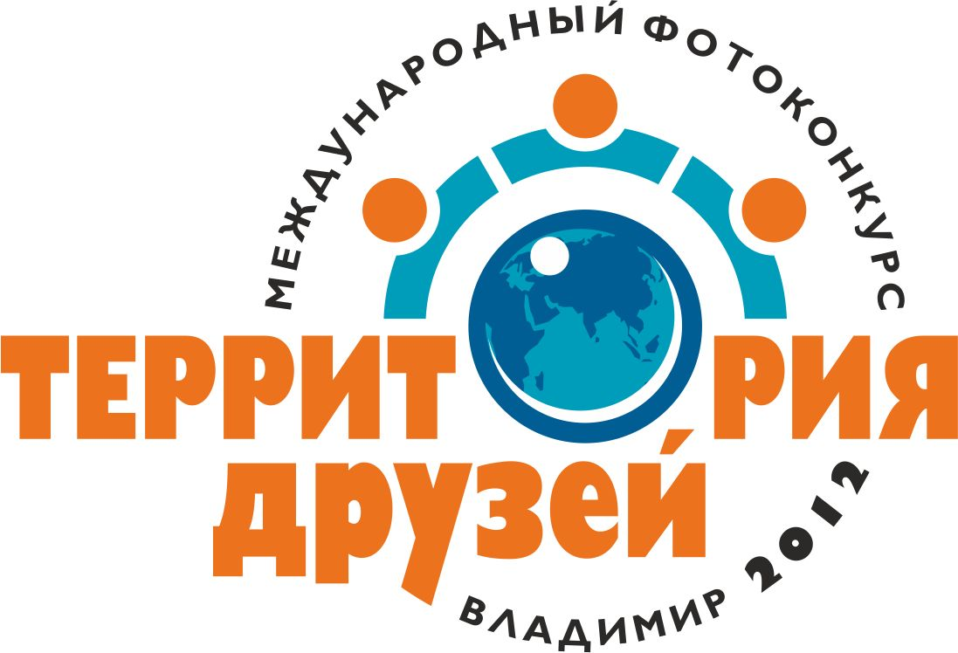 | Sister-city's international  photo contest  “Friends' Space”
ORGANIZERS & PARTNERS:
Administration of Vladimir city
Department of Culture & Tourism
Inter-regional Youth Public Organization “Peace Home”
Training Centre LLC “RASTI”
Vladimir Regional Union of Journalists
Photo Club “Vladimir”
Site “Virtual Vladimir” www.virtvladimir.ru

PARTICIPANTS:
Photo clubs, amateur and professional photographers from Vladimir city and from sister-cities of Vladimir.

TASKS & TARGETS OF THE PHOTO CONTEST:
* Popularization of the photography as a part of creative activity unifying people.
* Strengthening the intercultural cooperation and developing partner links.
* Acknowledgement of the national traditions and customs of the culture of the peoples, and developing the respect towards other national cultures.

INFORMATION FOR PARTICIPANTS:
Photo contest nominations
- People and everyday life
- Natural and urban landscape
- Traditions and customs
- The best city collection

All works should be sent electronically – maximum of 5 works per author, where one work is a set of no more than 6 photos. The size of each photo should not exceed 5MB.
Every work should include the title, author’s name, e-mail, country of residence and postal address (either in English or in Russian).
All works should be submitted before 10.08.2012 to this email address:ket@virtvkadimir.ru, tourism33@yandex.ru.
A competent jury will determine the authors of the best works. There will be three prizes awarded in each nomination. Different organizations and sponsors will provide special prizes.
The participation is free
The opening of the exhibition of the best works from the international photo contest “Friends’ Space” will take place in September 2012, on the Vladimir City Day.

Organizing committee:
Russia.Vladimir. B. Moskovskaya st.,59, 600000.
e-mail: tur@vladimir-city.ru, speche@mail.ru tel.: +007 (910) 779 43 15

